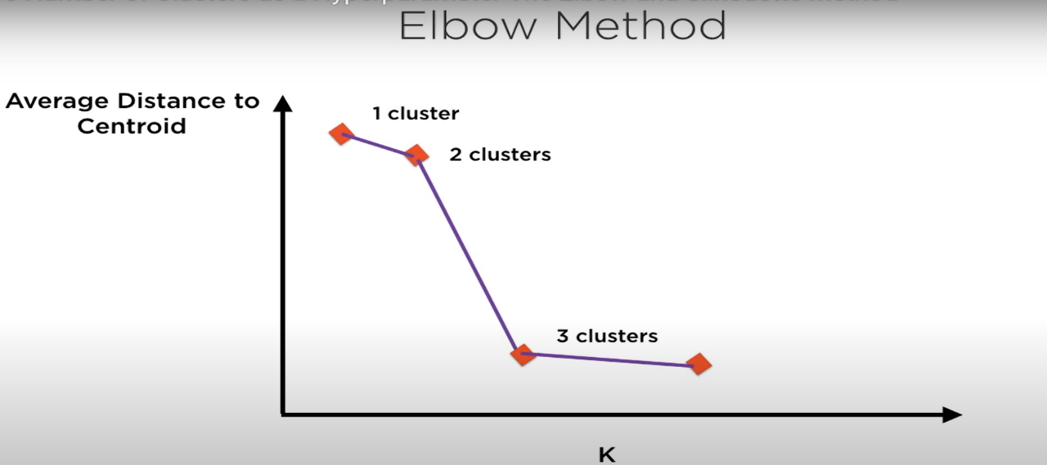

GOOD CENTROID TO PICK UP IS WHERE THE ELBOW OCCURS

